1. **ADD A PRIMARY KEY TO THE ID FIELDS IN THE PETS AND PEOPLE TABLES.**

**CODE:**

CREATE TABLE pets (

owner_id INT PRIMARY KEY, name VARCHAR(20));

INSERT INTO pets(owner_id, name) VALUES (001, 'kishore'), (002, 'bharath'), (003, 'Mahi');

Select * From pets;

**RESULTS:**

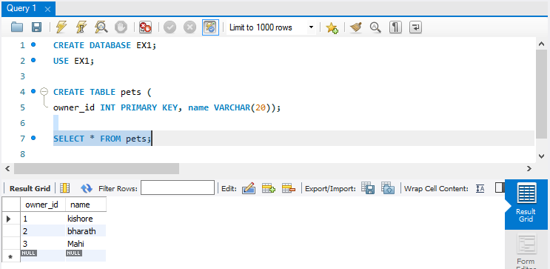

CREATE TABLE people (

owner_id INT PRIMARY KEY

);

**RESULTS:**

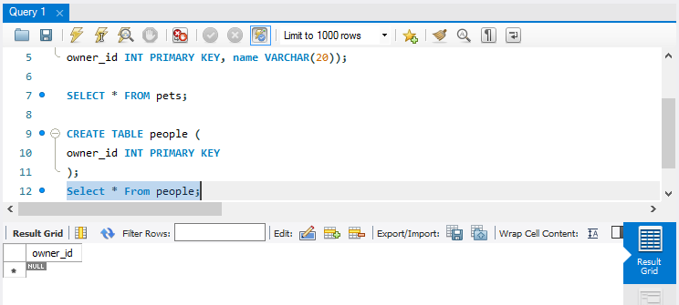

1. ADD A FOREIGN KEY TO THE OWNER_ID FIELDS IN THE PETS TABLE REFERNCING THE ID FIELD IN THE PEOPLE TABLE.

**CODE:**

ALTER TABLE pets ADD FOREIGN KEY (owner_id) REFERENCES people(owner_id);

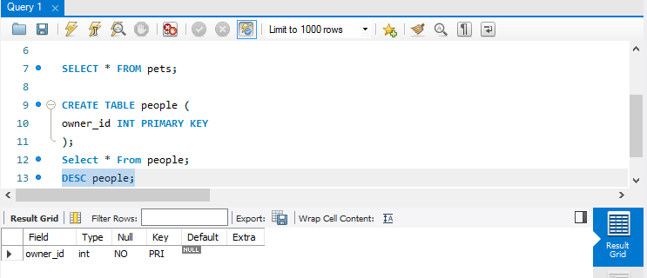

1. ADD A CLOUMN NAMED EMAIL TO THE PEOPLE TABLE.

**CODE:**

ALTER TABLE people ADD COLUMN email VARCHAR(30);

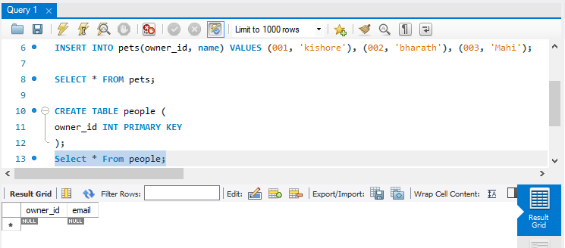

1. ADD A UNIQUE CONSTRAINT TO THE EMAIL COLUMN IN THE PEOPLE TABLE.

**CODE:**

ALTER TABLE people ADD CONSTRAINT UNIQUE(email);

RESULTS:

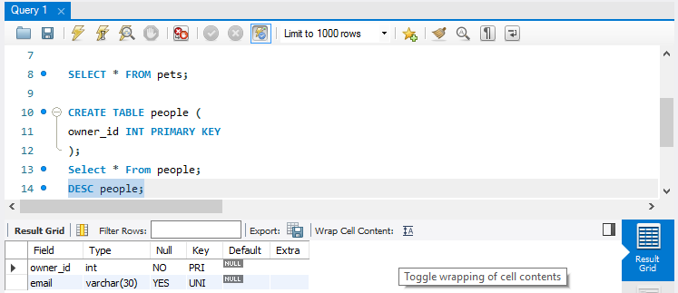

1. RENAME THE NAME COLUMN IN THE PETS TABLE TO FIRST_NAME.

CODE: ALTER TABLE pets RENAME column name TO first_name;

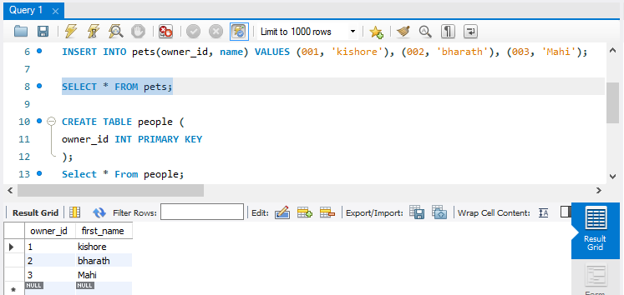

1. CHANGE THE POSTCODE DATA TYPE TO CHAR(7) IN THE ADDRESSES TABLE

**CODE:**

CREATE TABLE addresses(

postcode VARCHAR(10));

ALTER TABLE addresses MODIFY postcode CHAR(7);

INSERT INTO addresses(postcode) VALUES (600021);

Select * from addresses;

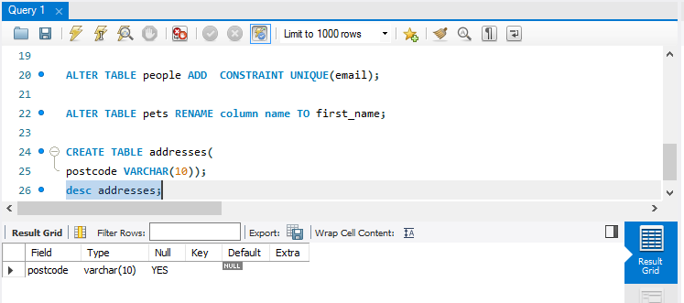

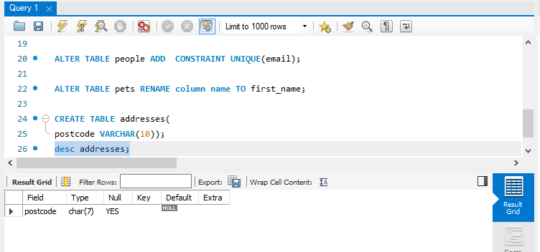

**EXERCISE -2**

1. From the customers table, select the first name and phone number of all the females who have a last name of bluth.

**CODE:**

CREATE TABLE customers(

ID INT AUTO_INCREMENT PRIMARY KEY,

first_name VARCHAR(20),

last_name VARCHAR(20),

sex VARCHAR(10),

phone_number VARCHAR(20));

Select * from customers;

INSERT INTO customers(first_name, last_name, sex, phone_number) VALUES

('Mahi','Bluth', 'female', 9874561230),

('Bharath', 'Bluth', 'male', 8844995672),

('sneha', 'Bluth', 'female', 9237568410),

('kirti', 'Bluth', 'female', 7756241687),

('Mahit','Bluth', 'male', ' '),

('naveen','kumar', 'male', ' '),

('ramesh', 'singh', 'male', ' ');

SELECT * FROM customers WHERE sex='female' and last_name='Bluth';

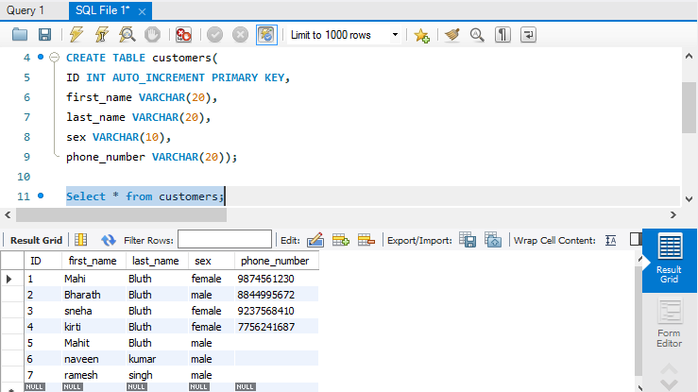

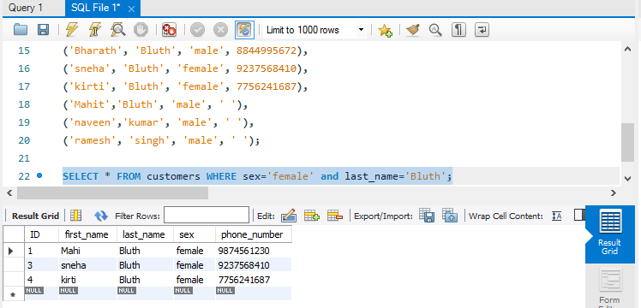

1. **From the products table, select the name for all products that have a price greater than 3.00 or a coffee origin of Srilanka.**

**Code:**

CREATE TABLE products(

ID INT AUTO_INCREMENT Primary key,

product_name VARCHAR(20), price float, origin VARCHAR(10));

SELECT * FROM products;

INSERT INTO products(product_name, price, origin) VALUES

('coffee', 3.00, 'srilanka'), ('coffee', 3.00, 'india'),

('Tea', 2.00, 'srilanka'), ('coffee', 5.00, 'srilanka'), ('coffee', 2.00, 'srilanka'),

('coffee', 7.00, 'usa'), ('Tea', 5.00, 'singapore'),

('sugar', 10.00, 'india'), ('Tea', 4.00, 'china'), ('Rice', 25.00, 'India');

SELECT * FROM products WHERE price >=3.00 OR product_name ='coffee' and origin ='srilanka';

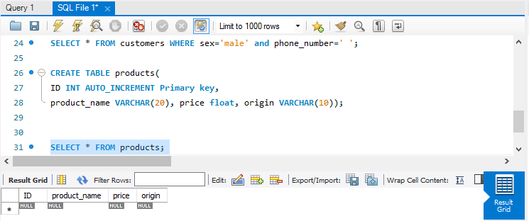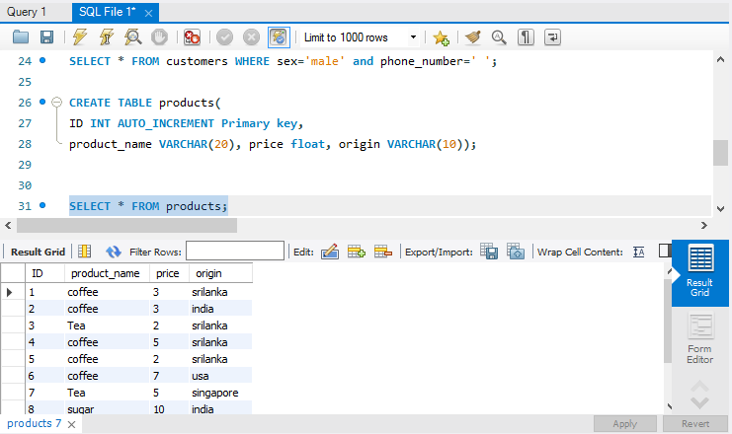

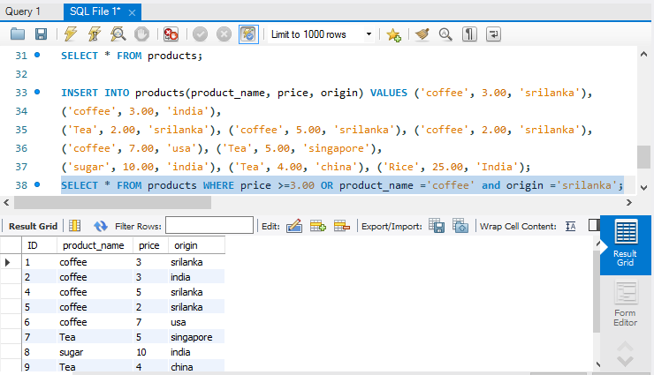

1. **How many male customers don’t have a phone number entered into the customers table.**

**CODE:**

SELECT * FROM customers WHERE sex='male' and phone_number=' ';

